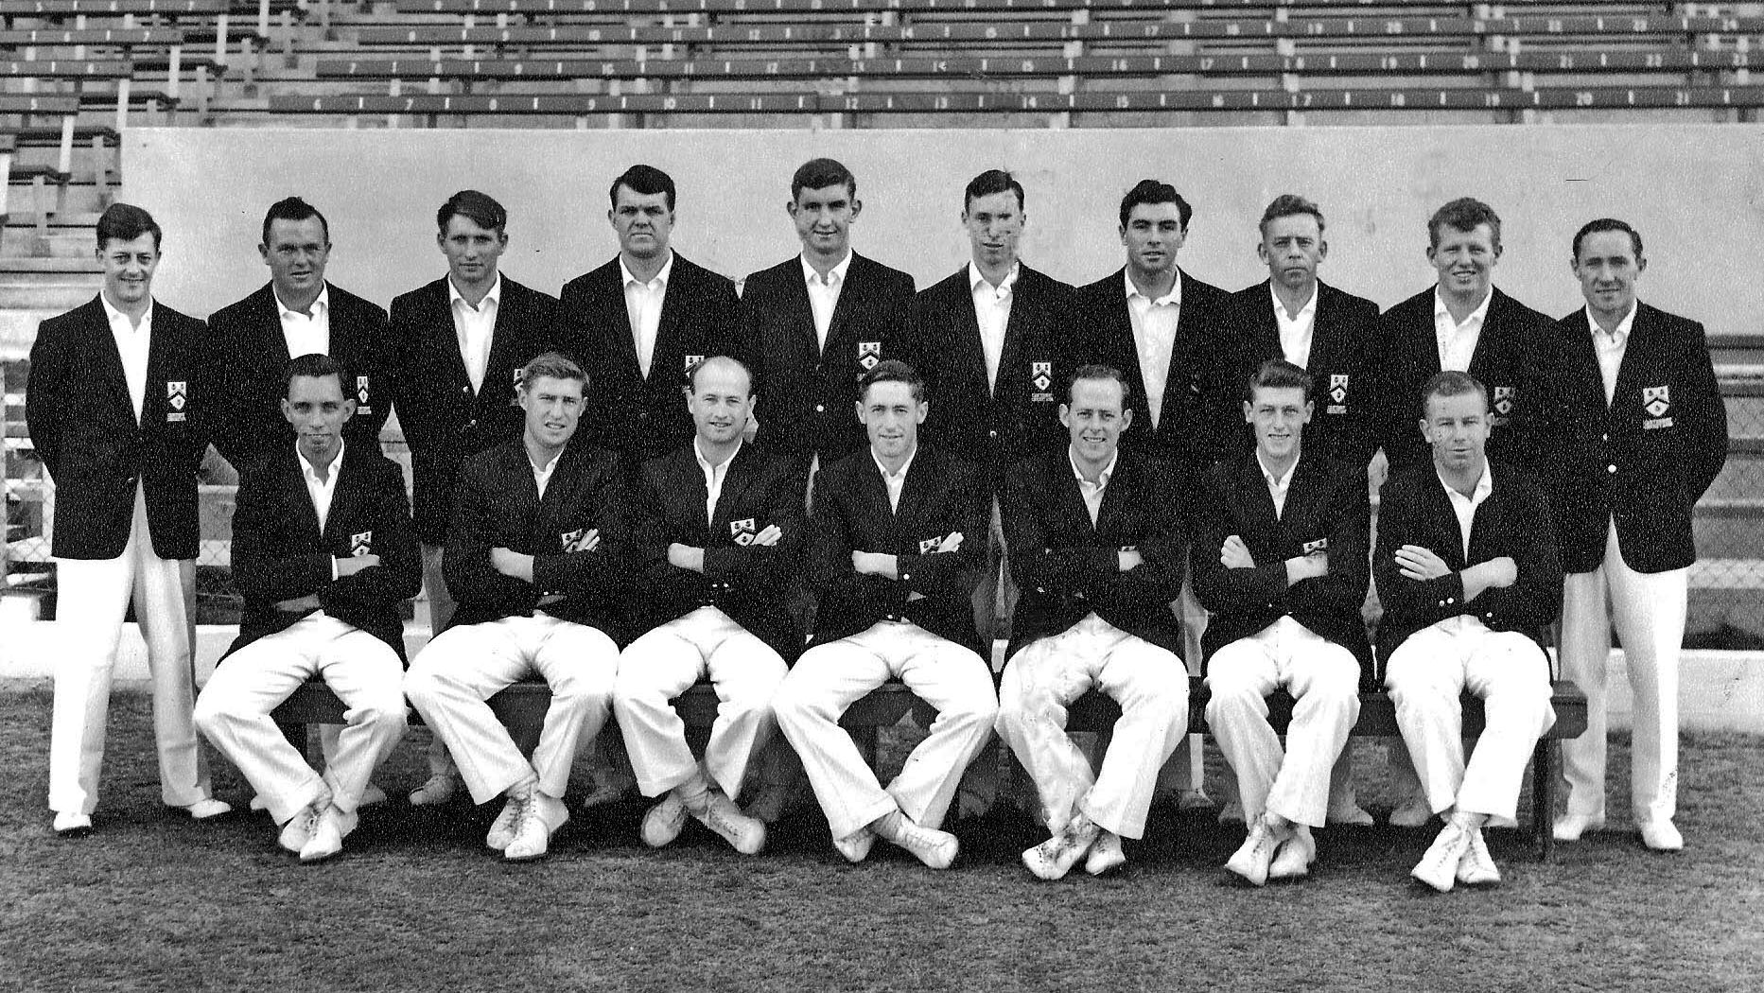

**Canterbury Representative Team 1963/64**

**Back row:** BA Bolton, K Thomson, RG Hortin, IR Hartland, B Andrews, BG Hadlee, GA Bartlett, JW Kiddey, CJ Stevens, BC Irving

**Front row:** PB Wight,RC Motz, PGZ Harris, GT Dowling (captain), BF Hastings, JT Ward, DL Gallop